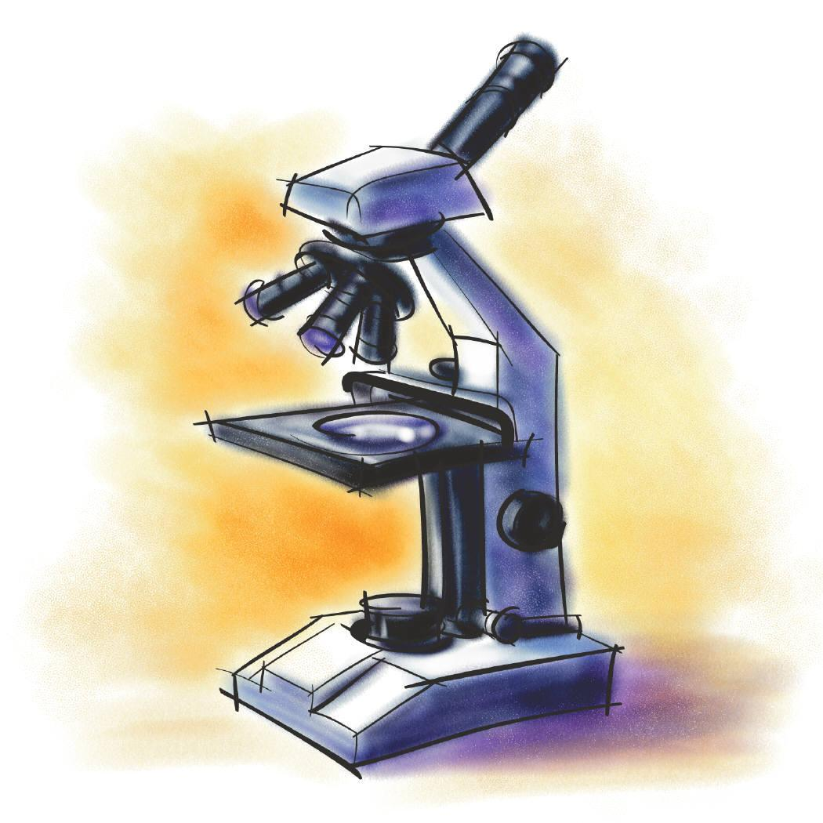
2021-2022 Science Fair Packet

Dear Students and Parents,

Attached to this letter is the 2021-2022 Science Fair Packet containing all the necessary information for the science fair project, which is due on Monday, Mar 1, 2022. Students in grades Kdg-8th Grade are required to participate in this exciting event. A science fair project can be an excellent learning experience and a memorable highlight of your child’s school years. During the next few weeks your child will design a science experiment that uses the scientific method to solve a problem. We hope you agree that the educational benefits are numerous, as students develop skills in reading, writing, oral presentation, creative thinking, mathematics, and problem solving.

Each student will be given instruction during class about the various steps of the scientific method. These steps have also been included in this packet. However, the work for your child’s specific science fair project will be completed at home. The information enclosed will provide you with a suggested timeline as well as an explanation of the project requirements. We encourage our students to choose projects that are original and challenging. Please refer to this timeline as you encourage your child to think scientifically.

We urge parents to help guide and monitor their child’s progress on the science fair project during the next several weeks. Your support is important to a successful project. However, do not allow your involvement to extend any further than that of a supportive role in order to assure equity and promote student learning. It is important that your child wrestles with problems and try to solve them. Guide your child whenever and wherever you can, but let the final project reflect your child’s individual effort and design. If you have any questions, do not hesitate to contact your child’s science teacher.

Thank you for your cooperation, and we look forward to watching your child enjoy this unique opportunity for scientific discovery!

Sincerely,
The Science Team

Science Fair Packet Distribution- December 1, 2021

Due Date for Science Fair Projects- March 1, 2022

SCIENCE FAIR PROJECT

GETTING STARTED

- Get started right away
- Science fair projects often require several weeks for completion.
- Don’t let a due date that is many weeks away throw your planning off--there are many things to do.
- Stay organized with a schedule
- With a long-range project it is very important to make a schedule and stay organized.
- There is no substitute for good planning.
- Have fun!

USING THE SCIENTIFIC METHOD

- Ask a question - topic and purpose:

- Ask a question about something that you observe: how, what, when, who, which, why, or where?
- The question must be about something that you can measure, preferably with a number.
- Your question is the topic of your project.
- Your question becomes the title for your project.
- Define the purpose of your project.
- Write one to three sentences explaining why you are doing this investigation.

2. Form a hypothesis:

- A hypothesis is an educated guess about how things work.
- Ask yourself the following question: "If I do this, then this will happen?"
- State your hypothesis in a way that you can easily observe and measure.
- Your hypothesis should be constructed in a way to help you answer your original question.
- Examples of a hypothesis for different questions:
Question: Does the brand of paper towel affect the amount of water it can absorb?
Two different examples of a possible hypothesis:
Hypothesis 1: Brand A absorbs more water than Brand B.
Hypothesis 2: Brand B absorbs more water than Brand A.

3. Test your hypothesis:

- It’s okay if your hypothesis is incorrect-that's how scientists make discoveries.
- It is important for your experiment to be a fair test by making sure that you change only one factor (variable) at a time while keeping all other conditions the same.
- You should also repeat your experiments several times to make sure that the first results weren't just an accident.
- Your experiment includes the materials, variables, and procedures which test whether your hypothesis is correct or incorrect.

a. Materials

- List all of the material used in your investigation.
- Include what, how much, and what kinds of materials you used.
- Keep track of the quantities of each item that you used.
- The following table is an example of a good material list and a poor material list:
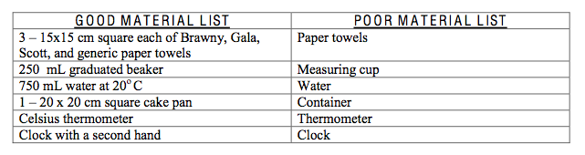

b. Variables

- A variable is the factor that you will be changing during your experiment to help answer your question and ultimately help to prove or disprove your hypothesis.
- There are two different types of variables:
1. Independent Variable – this is what you change on purpose in your experiment.
2. Dependent Variable – this is what changes by itself because you manipulated (changed) something in your experiment.
- Make sure you are only changing one independent variable at a time.
- Keep everything else constant and determine what the response is.
- The response will be the results of your experiment.
- Repeat this scenario several times to make sure you receive the same results.

c. Procedure

- The procedure lists the step-by-step directions of your experiences.
- Write the step-by-step directions of your experiment.
- These directions are like a recipe and anyone who reads them will be able to duplicate your experiment and have the same results.
- Here is an example of a procedure:
Question: Do all brands of paper towels absorb the same amount
of water?
- Cut 3 15 x 15 cm squares from each brand of paper towels
- Label each cut piece with brand name
- Pour 50 mL of 20o C water into 20 x 20 cm square pan
- Place one square of generic brand paper towel into water and pan
- Leave for 30 seconds
- Remove paper towel
- Measure water remaining in pan and record
- Dry the cake pan
- Repeat steps 4-8 for each brand of paper towel
- Repeat entire process twice more for each brand of paper towel

4. Analyze your data:

- Once your experiment is complete, collect your measurements.
- Analyze your measurements to see if your hypothesis was correct or incorrect.
- To help you analyze your results, draw graphs, charts, or illustrations.

- Consider taking photos during your experiments and use them to help analyze your results and for your display.
- When drawing a graph, plan your graph carefully so that your data will be evenly distributed across the horizontal and vertical axes.
- You may use bar graphs, line graphs, pie charts, or any other drawing that shows your data best.

5. Write your conclusion:

- When you feel your experiment is complete, it is time to write your conclusions.
- When writing your conclusions carefully examine all of your data, graphs, charts, tables and photos.
- Your conclusions should include:

a. A statement of support or of non-support of your original hypothesis.
b. A description of any problems or any unusual events that occurred during your
experiment
c. What you would do differently next time
d. A revised hypothesis if your experiment results did not support your original
hypothesis.

DISPLAYING YOUR SCIENCE PROJECT

- The purpose of your exhibit is to clearly and attractively show the results of your project to others.
- Your science projects will rest atop tables or may be on the floor. Your display MUST include:

- The title of project
- Your name, grade, and homeroom teacher
- Purpose- An explanation of your project
- Hypothesis
- List of materials used
- Procedure
- Data- charts, diagrams, graphs, or pictures helping to explain your project
- Your conclusion

4. Your display may NOT include the following:

- Living organisms, including plants
- Taxidermy specimens or parts
- Preserved vertebrate or invertebrate animals
- Human or animal food
- Laboratory/household chemicals
- Poisons, drugs, controlled substances, hazardous substances or devices (for example, firearms, weapons, ammunition, reloading devices)
- Dry ice or other sublimating solids
- Sharp items (for example, syringes, needles, pipettes, knives)
- Flames or highly flammable materials
- Batteries with open-top cells
- Glass or glass objects

5. Follow the diagram below and set your board up the same way:

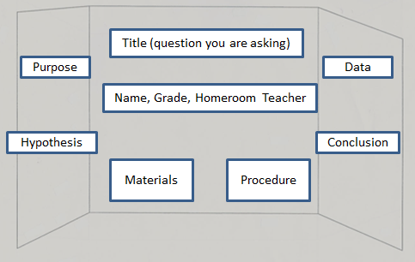

***We encourage you to take pictures of your experiment and display the photographs on your board***

Science Fair Project Proposal Form

Name ___________________
Date ___________________
Homeroom ___________________

Due Date:______________________

Project Topic: _____________________________________________________________________________

What is the question you are going to try to answer? _______________________________________________
_________________________________________________________________________________________

Write a brief description of the experiment you plan on doing: __________________________________________________________________________________________
________________________________________________________________________________________________________________________________________________________________________________________________________________________________________________________________________________________________________________________________________________________________________

Project accepted: Yes No Teacher’s Initials: _________________

Comments:
__________________________________________________________________________________________
______________________________________________________________________________________________________________________________________________________________________________________________________________________________________________________________________________

Student’s Name: ___________________________________________________ Grade: ________________

Teacher’s Name:_________________________________________________________________________

Science Fair Grading Rubric

Grading Rubric
 | Possible Points | Earned Points
Proposal | 2 points
Effort-Was there a degree of individual effort demonstrated? | 5 points
Final project turned in on time  Monday March 1, 2022 | 5 points
Presentation Boards included the following:
Title | 5 points
Name, grade, and homeroom teacher | 3 points
Question | 5 points
Hypothesis | 5 points
Materials were listed | 5 points
Procedure | 5 points
Data charts/graphs were included and labeled | 10 points
Conclusion | 10 points
Graphic display, drawings or photos of major steps of your project | 10 points
Oral Presentation (in class) | 30 points
Total | 100 points

